**CSE 115 – Introduction to Software Engineering**

**Sprint PlanTemplate**

The team needs to capture the result of their sprint planning meeting in a document with the structure outlined below. This document (as well as other project documents should be made accessible to the team’s TA (e.g., via shared Google docs or drive).

There is no further submission process. All project documents are created for the benefit of

your project and team, not the entertainment of the teaching staff.

**Heading:** Sprint 3 plan, World of Feel Well, FeelWell, Due 7/22/2024, (revision number & revision date)

**Goal:** Achieve minimum viable product and adequate polish.

∙

**Task listing, organized by user story:** This section lists the user stories, in priority order from

∙

most important (top) to least important (bottom). Within each user story, there needs to be a list of tasks required to implement the user story, along with the time estimate for each tasks (preferably less than or equal to 6 ideal hours). This should look like:

* {5}As a player, I want to be able to compete in a global leaderboard so I can satisfy my competitive desires. [8]
  + Create Front-end API that connects to the database [2 Hours]
  + Have database share top 10 players [3 Hours]
  + Create UI in Homescreen [5 Hours]
* As a player, I want to be able to gain experience after completing a quest and get punished if I don’t do enough quests.
  + Back end for exp-bar [2 Hours]
  + Back end for health-bar [2 Hours]
* {3}As a player, I want to have daily/weekly “quests” that I can work towards
  + JS backend to update the progress bars according to checked off task in scheduler [3 Hours]
  + styling for random generated quote button / quote [1 Hour]
* {4}As a player, I want to have a customizable profile that is visible to other users displaying my accomplishments (badges?) [8]
  + badge design [1 Hours]
  + Tool tip to display description of each badge
  + Display the badges received on profile page

**Team roles:** Give a listing of all team members. Next to the team member, list their role(s) for

∙

this sprint. Assign each person to at least one role (for example, this role might be "Developer"). This looks like:

Aidan Adair: Developer

Harry Dole: Product Owner/Developer

Kevin Tran: Developer

Julian Chop: Developer

Erick Hernandez: Scrum Master/Developer

∙ **Initial task assignment:** A listing of each team member, with their first user story and task assignment. This should look like:

Aidan Adair: JS backend to update the progress bars according to checked off task in scheduler

Harry Dole: Badge Design

Kevin Tran: JS Backend for health and exp bar

Julian Chop:

Erick Hernandez: Create Front-end API that connects to the database

∙ **Initial burnup chart:** A graph giving the initial burnup chart for this sprint and is labeled as such

with sprint number and project name and is located in the lab.

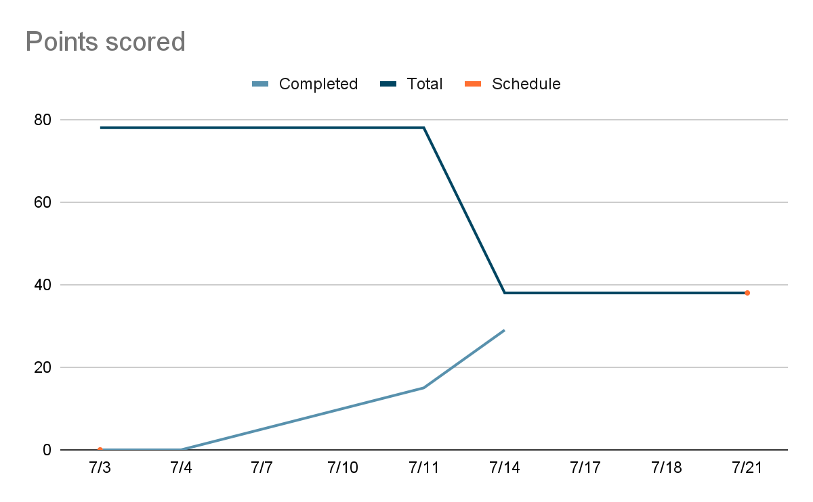

**Initial scrum board:** <https://trello.com/b/AmTWVAyh/feelwell-team>

**Scrum times:**

M: 3:30pm

W: 6:00pm

F: 3:30pm

Last modified: 2023 06 25 (adapted from materials for cmps115)